**Static and non-static**

**Static**

* Any member with is declared with the keyword static is called as static member of the class.
* Static is always associated with class.
* Static is always single copy.
* All the static member are stored in static pool area.
* Whenever we want to access from static from static we use

Class_name.method_name or Class_name.variable_name

Example

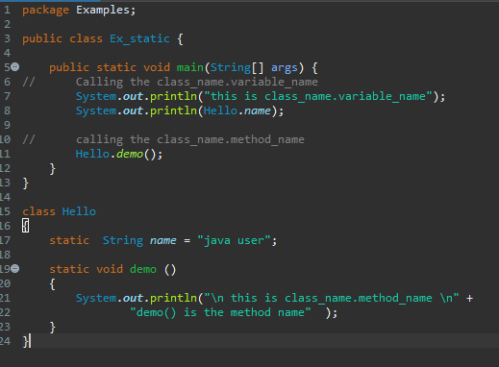

Static with arguments

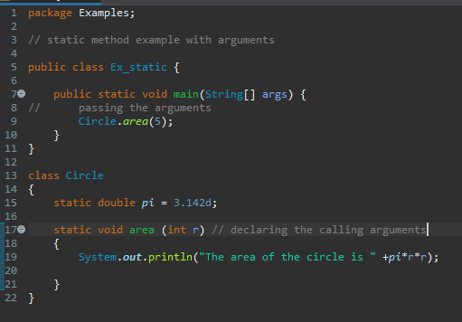

Static with return type

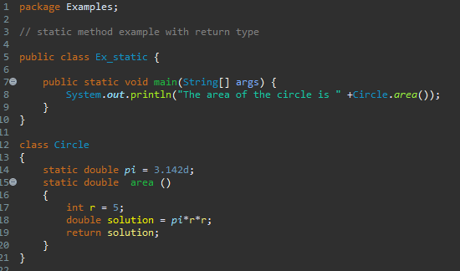

Static with return type and arguments

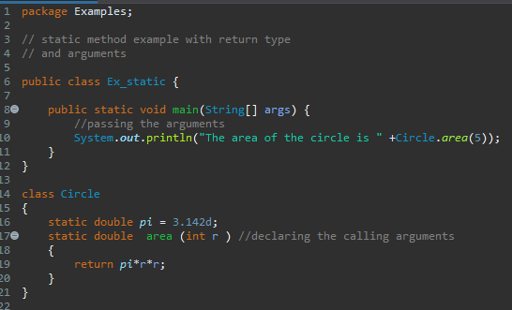

**Non-static**

* Any memberwithout the keyword static is called as non-static member of class.
* Non-static is associated with object.
* Non-static is always multiple copies.
* Non-static is members are stored in heap memory.
* Whenever we want to access from non-static to static we use

Object.method_name / object.variable_name

Or

Reference_variable.method_name / Reference_variable.variable _name

Syntax for creating object

New class_name

new is an operator class_name is a constructor

Object

it will create a random which is used to initialize all the

memory space in the non-static member into the

heap memory heap memory

Example

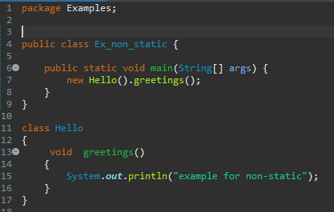

With arguments

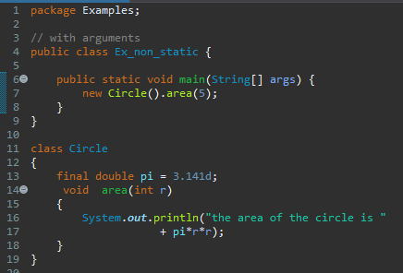

With return type

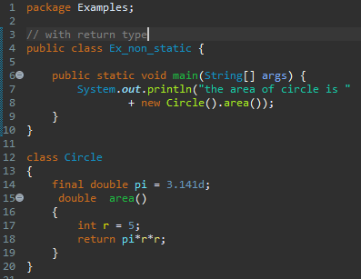

Return type with arguments

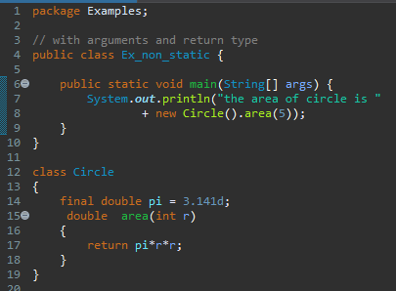

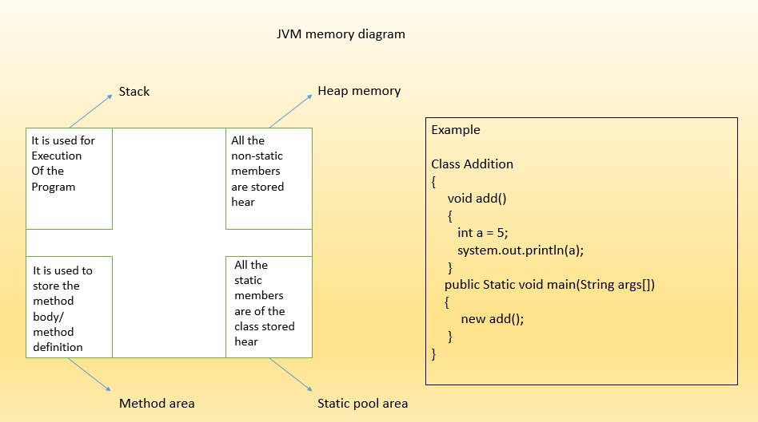

Practice programs

1. Addition, subtraction, multiplication, division of 2 number using static and non-static.
2. Find square of a number using static and non-static.
3. Area of triangle using static and non-static.